Hesperus Camp
Women’s Retreat
May 1-2, 2020
Refuge in Life Storms
Psalms 107:28-29

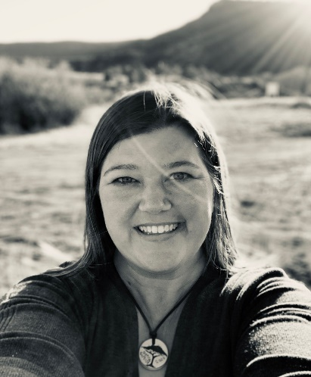

Guest Speaker, Beverly Wilson

Serena Wilson is a follower of Jesus. She likes to think herself a domestic engineer which equates to a homeschool mama that spends lots of time pretending she has it all together, unclogging toilets, changing lightbulbs, problem solver, personal chef and a soft place to land for her husband and children. She is an average woman who seeks to glorify God through her life and family. Her story and testimony show God’s grace through her journey in becoming a women who intentionally seeks after Him. Her desire is for women of all ages to have a hunger for Jesus. She and her husband, Scott, reside in Albuquerque, NM with their three children Kaleb, Kylie and Kennah

- 3 – 5 registration, disc golf, mingle, fellowship, and zip line activity (optional, $20/person)
- 5pm – Get to know everyone, then supper at 6 pm
- Lodging is first come first serve, lodge rooms $76 (linens provided) and cabins $45 (brings your own linens)
- If not spending the night cost is $20/per day which includes meals, both days would be $40
- Each church will designate one person to gather registrations and call Hesperus Camp (970) 385-4389 to reserve lodging for their church by April 17th. Send registration form with deposit of $10/person as well. Late registration will be accepted but the camp needs a total number for food preparation
- Due to camp licensing no outside food can be brought, if allergies or heath concerns please contact the camp (970) 385-4389 so arrangements can be handled.
- If questions please contact Bryan Maxey at 505-947-1583 or bryan@hesperuscamp.com

